SPARTA
UNITED METHODIST CHURCH
Open Hearts, Open Minds, Open Doors

August 1, 2021 10:30 a.m.

Prelude Let Us Break Bread Together Spiritual arr. Albert Zabel

Welcome and Announcements

Call to Worship

Hear these words about love from the Scriptures:
“Beloved, let us love one another, because love is from God.”
“You shall love your neighbor as yourself.”
“You shall love the Lord your God with all your heart, and with all your soul,
and with all your mind.”
“God so loved the world.”
God so loves the world. So let us worship the God of love and life.

Opening Song Come, Christians Join to Sing UMH 158

Opening Prayer

Holy Triune God, the winds of your Spirit beckon us to follow, but we cannot hear the wind over the noise we have created. Again and again, you call us to believe. Again and again, we look the other way. You offer us freedom, but we choose independence, pretending that we have ultimate control. You offer us life, but we find ourselves perishing buried under the weight of our own self-interest. Forgive us, God of life. Heal us, and bring us peace that we might live a life of abundance and grace in the light of Christ. For it is in Christ’s name that we pray the prayer he taught us:

The Lord’s Prayer Ian Good

A Time for Young Disciples

Special Music Swing Lo, Sweet Chariot
Spiritual arr. Nancy Hascall
Yvonne Roux, Handbells

Gospel Reading John 3:14-17

¹⁴ And just as Moses lifted up the serpent in the wilderness, so must the Son of Man be lifted up, ¹⁵ that whoever believes in him may have eternal life. ¹⁶ “For God so loved the world that he gave his only Son, so that everyone who believes in him may not perish but may have eternal life. ¹⁷ “Indeed, God did not send the Son into the world to condemn the world, but in order that the world might be saved through him.

The Message Life Eternally

Offering of Our Gifts and our Prayers

The Celebration of the Lord’s Supper
The Lord be with you.
And also with you.
Lift up your hearts.
We lift them up to the Lord.
Let us give thanks to the Lord our God.
It is right to give our thanks and praise.

It is right, and a good and joyful thing . . .
we praise your name and join their unending hymn:

Holy, holy, holy Lord, God of power and might,
heaven and earth are full of your glory.
Hosanna in the highest.
Blessed is he who comes in the name of the Lord.
Hosanna in the highest.

Holy are you, and blessed is your Son Jesus Christ…as we proclaim the mystery of faith.

Christ has died; Christ is risen; Christ will come again.

Receiving of the Bread and the Cup

Closing Song We’ve a Story to Tell to the Nations UMH 569

The Sending Forth

Postlude All Creatures of Our God and King arr. Mark Hayes

Thoughts and Prayers
Peg Pierson, Iggy, Wayne Mackey, Joann Stiles, Pat Johnson

WELCOME TO ALL

Who hope for a better world
& all who have lost hope:

Believers and seekers
Conventional Christians & questioning skeptics

Women, men, youth and children

Of all sexual orientations & gender identities

Of all races and cultures,

Of all income levels

Of all social classes

Of all physical & mental abilities.

COME AS YOU ARE . . .

YOU ARE WELCOME!

SPARTA
UNITED METHODIST CHURCH

Ministry Team

MINISTERS Every member of Sparta UMC
PASTOR Rev. Dr. Steven Bechtold
PASTOR EMERITUS Rev. Dr. Alden Welch
ADMINISTRATIVE ASSISTANT Karen Shaw
DIRECTOR OF MUSIC MINISTRIES Ian Good
DIRECTOR OF YOUTH MINISTRIES & SUNDAY SCHOOL
SEXTON Eleanor Shumaker

WEBSITE: www.spartaumc.org
Come, Christians Join to Sing, Words: Christian Henry Bateman, 1843, Music: Trad. melody, arr. by Benjamin Carr, 1824; harm. by Austin C. Lovelace, 1963
We’ve a Story to Tell to the Nations, Words & Music: H. Ernest Nichol, 1896
All songs - CCLI 11297801

SPARTA
UNITED METHODIST CHURCH

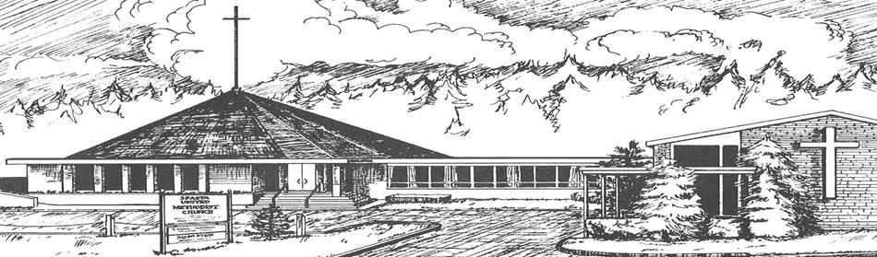

August 1, 2021

10:30 a.m. Worship Service

71 Sparta Avenue
Sparta, New Jersey 07871

Open hearts, Open minds, Open doors:
Not Just a Tagline: This IS who we are

