SPARTA
UNITED METHODIST CHURCH
Open Hearts, Open Minds, Open Doors

October 24, 2021 10:30 a.m.

Prelude Deck Thyself, My Soul, with Gladness
G.F. Handel arr. Hal Hopson

Welcome and Announcements
*Call to Worship
Come and rejoice in God!
Sing praise to God who continually blesses our lives!
In the midst of troubles and stress, God is near, offering compassion.
Our hope is in the Lord.
Let all the people praise God.
*Opening Song of Praise Sing Praise to God Who Reigns Above UMH 126
Opening Prayer
Lord, we have come to this place from a world of demands and schedules. We have sought hope and peace and have found them here. Now we seek the inner joy that only your presence can bring to our lives. Open our hearts and our spirits to your love. In times of difference and division, save us from rancor and meanness. Help us focus ourselves on things that are excellent and worthy. Make us witnesses to your way of justice and righteousness. Transform us and transform the world, for we pray in the name of Jesus who taught us to pray saying

The Lord’s Prayer Ian Good

A Time for Young Disciples

Scripture Lesson Philippians 4:10-20
¹⁰ I rejoice in the Lord greatly that now at last you have revived your concern for me; indeed, you were concerned for me, but had no opportunity to show it. ¹¹ Not that I am referring to being in need; for I have learned to be content with whatever I have. ¹² I know what it is to have little, and I know what it is to have plenty. In any and all circumstances I have learned the secret of being well-fed and of going hungry, of having plenty and of being in need. ¹³ I can do all things through him who strengthens me. ¹⁴ In any case, it was kind of you to share my distress.
¹⁵ You Philippians indeed know that in the early days of the gospel, when I left Macedonia, no church shared with me in the matter of giving and receiving, except you alone. ¹⁶ For even when I was in Thessalonica, you sent me help for my needs more than once. ¹⁷ Not that I seek the gift, but I seek the profit that accumulates to your account. ¹⁸ I have been paid in full and have more than enough; I am fully satisfied, now that I have received from Epaphroditus the gifts you sent, a fragrant offering, a sacrifice acceptable and pleasing to God. ¹⁹ And my God will fully satisfy every need of yours according to his riches in glory in Christ Jesus. ²⁰ To our God and Father be glory forever and ever. Amen.
The Anthem Every Good Gift Comes from God James M. Stevens
The Message Blessed to Bless
Offering of our Gifts and our Prayers
*Closing Song Grace Alone FWS 2162
Sending Forth
Postlude Fugue and Harmonization on "St. Anne"
J.S. Bach arr. Hal Hopson

Thoughts and Prayers

Please keep the families of Dianne Refsland, Hugh Krone, Joann Stiles
and Estelle Lehmkuhl in your prayers.

Continue to pray for: Phyllis Blessing, Phoebe Rude, Peg Pierson, Iggy,
Wayne Mackey, Pat Johnson
* Stand if able
WELCOME TO ALL

Who hope for a better world
& all who have lost hope:

Believers and seekers
Conventional Christians & questioning skeptics

Women, men, youth and children

Of all sexual orientations & gender identities

Of all races and cultures,

Of all income levels

Of all social classes

Of all physical & mental abilities.

COME AS YOU ARE . . .

YOU ARE WELCOME!

SPARTA
UNITED METHODIST CHURCH

Ministry Team

MINISTERS Every member of Sparta UMC
PASTOR Rev. Dr. Steven Bechtold
PASTOR EMERITUS Rev. Dr. Alden Welch
ADMINISTRATIVE ASSISTANT Karen Shaw
DIRECTOR OF MUSIC MINISTRIES Ian Good
DIRECTOR OF YOUTH MINISTRIES & SUNDAY SCHOOL
SEXTON Eleanor Shumaker

WEBSITE: www.spartaumc.org

Sing Praise to God Who Reigns Above, Words: Johann J. Schutz, 1675, Music: Bohemian Brethren’s Kirchengesange, 1566, harm. by Maurice F. Bell, 1906
Grace Alone, Words & Music: Scott Wesley Brown and Jeff Nelson
All Songs One License A-719583

SPARTA
UNITED METHODIST CHURCH

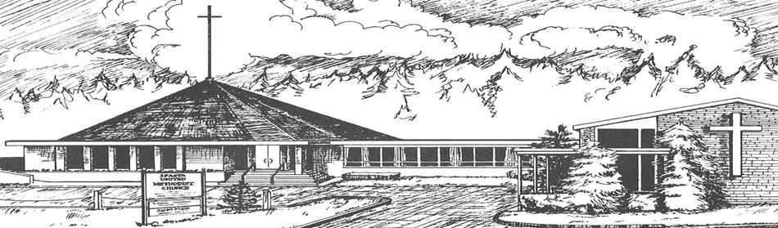

October 24, 2021

10:30 a.m. Worship Service

71 Sparta Avenue
Sparta, New Jersey 07871

Open hearts, Open minds, Open doors:
Not Just a Tagline: This IS who we are

