SPARTA
UNITED METHODIST CHURCH
Open Hearts, Open Minds, Open Doors

May 22, 2022 10:30 a.m.

Prelude All Things Bright and Beautiful John Rutter

Welcome and Announcements

*Call to Worship

We meet as a family in the presence of our loving, sustaining God.
We meet as brothers and sisters in Christ, accepting the responsibility that this places upon us to love one another as you have loved us.
We meet as your lights in this dark world and pray that through our words and our lives others might be drawn into your family
We meet to seek shalom with all people in this place and all people in our world.

*Opening Song My Life is in You, Lord FWS 2032

Opening Prayer

Lord, you know how easy it is for us to sit here, tethered to fear and darkness, bound up by chains of mistrust. We dare not to hope so as to avoid disappointment. We fail to see you drawing near to us when we are surrounded by uncertainty or insecurity, buy you are there. Flood us with your powerful light of love and mercy. Help open our eyes to the good news of your grace. Give to us visions of the place in which love and hope will reign. Forgive our stubborn resistance to your mercy and your love so that we might embrace the abundance of living that you have shown us in your Son, Jesus, who taught us to pray saying:

The Lord’s Prayer Ian Good

Anthem The Colors of Your Grace Mark Hayes

A Time for Young Disciples

Song of Preparation Sanctuary FWS 2164

Scripture Lesson Ephesians 4:17-24

¹⁷ Now this I affirm and insist on in the Lord: you must no longer walk as the gentiles walk, in the futility of their minds; ¹⁸ they are darkened in their understanding, alienated from the life of God because of their ignorance and hardness of heart. ¹⁹ They have lost all sensitivity and have abandoned themselves to licentiousness, greedy to practice every kind of impurity. ²⁰ That is not the way you learned Christ! ²¹ For surely you have heard about him and were taught in him, as truth is in Jesus, ²² to put away your former way of life, your old self, corrupt and deluded by its lusts, ²³ and to be renewed in the spirit of your minds, ²⁴ and to clothe yourselves with the new self, created according to the likeness of God in true righteousness and holiness.

Bell Anthem Acclamation in G Minor by Karen Thompson

The Message Renewal

The Offering of Our Gifts and our Prayers

*Closing Song Precious Name UMH 536

Sending Forth

Postlude All Hail the Power of Jesus' Name arr. Brent Edstrom

Thoughts and Prayers
Rich Kelley, Linda Giammanco Joel, Phoebe Rude, Brenda Losey, Wayne Mackey

* Stand if able

WELCOME TO ALL

Who hope for a better world
& all who have lost hope:

Believers and seekers
Conventional Christians & questioning skeptics

Women, men, youth and children

Of all sexual orientations & gender identities

Of all races and cultures,

Of all income levels

Of all social classes

Of all physical & mental abilities.

COME AS YOU ARE . . .

YOU ARE WELCOME!

SPARTA
UNITED METHODIST CHURCH

Ministry Team

MINISTERS Every member of Sparta UMC
PASTOR Rev. Dr. Steven Bechtold
PASTOR EMERITUS Rev. Dr. Alden Welch
ADMINISTRATIVE ASSISTANT Karen Shaw
DIRECTOR OF MUSIC MINISTRIES Ian Good
DIRECTOR OF YOUTH MINISTRIES & SUNDAY SCHOOL Jack Tironi
SEXTON Eleanor Shumaker

WEBSITE: www.spartaumc.org

My Life is in You, Lord, Words & Music: Daniel Gardner - CCLI 11297801
Sanctuary, Words & Music: John Thompson and Randy Scruggs - One License A-719583
Precious Name, Words: Lydia Baxter, 1870; Music: William H. Doane, 1871 - One License A-719583

SPARTA
UNITED METHODIST CHURCH

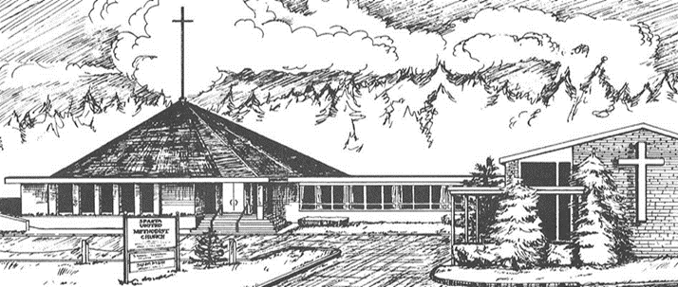

May 22, 2022

10:30 a.m. Worship Service

71 Sparta Avenue
Sparta, New Jersey 07871

Open hearts, Open minds, Open doors:
Not Just a Tagline: This IS who we are

