SPARTA
UNITED METHODIST CHURCH
Open Hearts, Open Minds, Open Doors

August 21, 2022 10:30 a.m.

Prelude How Firm a Foundation Early American Melody
Arr by Laura Keiter

Welcome and Announcements

*Call to Worship adapted from 2 Corinthians 5: 17-19

If anyone is in Christ, there is a new creation: everything old has passed away; look, new things have come into being
All this is from God, to whom we are reconciled through Christ and from whom we have been given the ministry of reconciliation.
In Christ, the world is reconciled to God; our trespasses are wiped away and we are entrusted with a message of newness.
So let us worship God with joy and hope, for God’s goodness blesses us in this and every moment!

*Opening Song God Is Here Today FWS 2049

Congregational Prayer

Loving and forgiving God, we turn to you this day knowing that we are not perfect people. We have fallen short of the image in which you have made us. We have not always sought peace; we have viewed one another with suspicion rather than acceptance. We have focused on scarcity rather than the abundance of life provided for us. Yet our hope lies in your love and forgiveness, for we know that you continually reach out to us and restores us continually. Help us to live as reconciled people who not only are embraced by your love, but as people who embrace others with the love as Christ as shown us. Help us to embrace the blessing and focus on the hope and the peace that you have shown us through your Son, Jesus, who taught us to pray saying:

The Lord’s Prayer Ian Good

A Time for Young Disciples
Song of Preparation Standing in the Need of Prayer UMH 352

Scripture Readings Genesis 33:4-11; 45:4-9

⁴ But Esau ran to meet him and embraced him and fell on his neck and kissed him, and they wept. ⁵ When Esau looked up and saw the women and children, he said, “Who are these with you?” Jacob said, “The children whom God has graciously given your servant.” ⁶ Then the maids drew near, they and their children, and bowed down; ⁷ Leah likewise and her children drew near and bowed down; and finally Joseph and Rachel drew near, and they bowed down. ⁸ Esau said, “What do you mean by all this company that I met?” Jacob answered, “To find favor with my lord.” ⁹ But Esau said, “I have enough, my brother; keep what you have for yourself.” ¹⁰ Jacob said, “No, please; if I find favor with you, then accept my present from my hand, for truly to see your face is like seeing the face of God, since you have received me with such favor. ¹¹ Please accept my gift that is brought to you, because God has dealt graciously with me and because I have everything I want.” So he urged him, and he took it.
⁴ Then Joseph said to his brothers, “Come closer to me.” And they came closer. He said, “I am your brother, Joseph, whom you sold into Egypt. ⁵ And now do not be distressed or angry with yourselves because you sold me here, for God sent me before you to preserve life. ⁶ For the famine has been in the land these two years, and there are five more years in which there will be neither plowing nor harvest. ⁷ God sent me before you to preserve for you a remnant on earth and to keep alive for you many survivors. ⁸ So it was not you who sent me here but God; he has made me a father to Pharaoh and lord of all his house and ruler over all the land of Egypt. ⁹ Hurry and go up to my father and say to him, ‘Thus says your son Joseph, God has made me lord of all Egypt; come down to me; do not delay.

The Message As We Forgive

Offering of our Gifts and our Prayers

*Closing Song Victory in Jesus UMH 370

Sending Forth

Postlude Wonderful Words of Life Philip P. Bliss

Thoughts and Prayers
The Family of Wayne Mackey, Mary Burke, Rich Kelley, Linda Giammanco,
Joel, Phoebe Rude, Brenda Losey

* Stand if able

WELCOME TO ALL

Who hope for a better world
& all who have lost hope:

Believers and seekers
Conventional Christians & questioning skeptics

Women, men, youth and children

Of all sexual orientations & gender identities

Of all races and cultures,

Of all income levels

Of all social classes

Of all physical & mental abilities.

COME AS YOU ARE . . .

YOU ARE WELCOME!

SPARTA
UNITED METHODIST CHURCH

Ministry Team

MINISTERS Every member of Sparta UMC
PASTOR Rev. Dr. Steven Bechtold
PASTOR EMERITUS Rev. Dr. Alden Welch
ADMINISTRATIVE ASSISTANT Karen Shaw
DIRECTOR OF MUSIC MINISTRIES
DIRECTOR OF YOUTH MINISTRIES & SUNDAY SCHOOL Jack Tironi
SEXTON Eleanor Shumaker

WEBSITE: www.spartaumc.org

God Is Here Today, Words: Trad. Mexican; trans, by C. Michael Hawn;
Music: Trad. Mexican; arr. by C. Michael Hawn & Arturo Gonzalez - One License A-719583
Standing in the Need of Prayer, Words: Afro American spiritual; Music: Afro-American spiritual;
arr. by William Farley Smith, 1986 - One License A-719583
Victory in Jesus, Words & Music: Eugene M. Bartlett, 1939, CCLI 11297801

SPARTA
UNITED METHODIST CHURCH

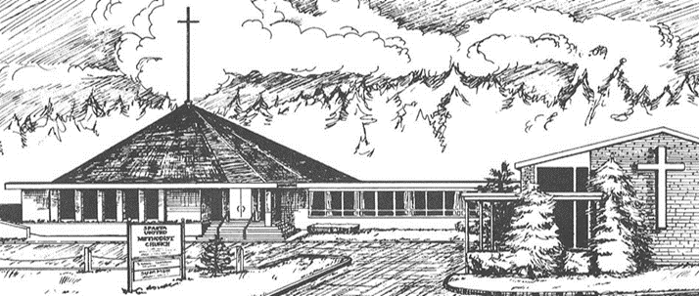

August 21, 2022

10:30 a.m. Worship Service

71 Sparta Avenue
Sparta, New Jersey 07871

Open hearts, Open minds, Open doors:
Not Just a Tagline: This IS who we are

