SPARTA
UNITED METHODIST CHURCH
Open Hearts, Open Minds, Open Doors

November 27, 2022 10:30 a.m.
The First Sunday in Advent

Prelude O Come, O Come, Emmanuel Adapted from Plainsong
by Thomas Helmore Arranged by John DeVries

Words of Welcome

Bell Tree Come, Thou Long Expected Jesus

The Lighting of the Advent Wreath The Light Awaits

O Come, let us walk in the light of the Lord.
The days darken, the nights grow longer. We long for the gift of light.
Open the doors of your heart, prepare room for the coming Christ.
As we worship today, may the doors of our hearts be open to the light of world, Jesus the Christ.

*Opening Song I Want to Walk as a Child of the Light UMH 206

Opening Prayer

The season is upon us once again, O God, when we prepare ourselves for the celebration of the birth of love incarnate, Jesus Christ. We are grateful that your invite us to prepare to make room for him in our lives, to find our best selves, to be willing to open the door to welcome the new life that comes to us as a newborn baby: vulnerable, ready to grow, ready to experience the fullness of life. May we hear that gentle knocking of your son on the doors of our hearts, so that the light of love and hope may flood any darkness dwelling in our lives, and we might share the light of the one who came to save, Jesus the Christ, who taught us to say praying:

The Lord’s Prayer Ian Good

Bell Anthem

Dedication of New Bells

Today we dedicate a series of new bells given in loving memory of
Wilma Smith by her family and other loved ones.
It is good to give thanks to the Lord,
To sing praises to your name, O Most High.
To declare your steadfast love in the morning
And your faithfulness at night
To the music of the lute and the harp,
To the melody of the lyre.
For you, O Lord, have made me glad by your work;
At the works of your hands I sing for joy.

A Time for Young Disciples

Anthem Come, Thou Long Expected Jesus by Mark A. Miller
Text by Charles Wesley

Reading of the Scripture Isaiah 2:1-5

The word that Isaiah son of Amoz saw concerning Judah and Jerusalem.
² In days to come the mountain of the Lord’s house shall be established as the highest of the mountains and shall be raised above the hills; all the nations shall stream to it. Many peoples shall come and say, “Come, let us go up to the mountain of the Lord, to the house of the God of Jacob, that he may teach us his ways and that we may walk in his paths.” For out of Zion shall go forth instruction and the word of the Lord from Jerusalem. ⁴ He shall judge between the nations and shall arbitrate for many peoples; they shall beat their swords into plowshares
and their spears into pruning hooks; nation shall not lift up sword against nation; neither shall they learn war any more. ⁵ O house of Jacob, come, let us walk in the light of the Lord!

The Message The Promise of Peace

This Week in the Life of the Church

The Offering of Our Gifts and Our Prayers

*Closing Song Star Child FWS 2095

*Sending Forth

Bell Tree Come, Thou Long Expected Jesus

Postlude In Dulci Jubilo by J. S. Bach

Thoughts and Prayers
Kathi, Craig, & Debbie Dickerson on the passing of Kathi’s husband & Craig’s father,
Sharon Gordon, Kathy Scehovic, Karen Sutphen, Lester Hemphill,
Pat Darnstead’s sister, Edith, and prayers for Pat and Tom, her caretakers, Rich Kelley,
Linda Giammanco, Joel, Phoebe Rude, Brenda Losey, Ken Bechtold
* Stand if able
WELCOME TO ALL

Who hope for a better world
& all who have lost hope:

Believers and seekers
Conventional Christians & questioning skeptics

Women, men, youth and children

Of all sexual orientations & gender identities

Of all races and cultures,

Of all income levels

Of all social classes

Of all physical & mental abilities.

COME AS YOU ARE . . .

YOU ARE WELCOME!

SPARTA
UNITED METHODIST CHURCH

Ministry Team

MINISTERS Every member of Sparta UMC
PASTOR Rev. Dr. Steven Bechtold
PASTOR EMERITUS Rev. Dr. Alden Welch
ADMINISTRATIVE ASSISTANT Karen Shaw
DIRECTOR OF MUSIC MINISTRIES Bonnie Pomeroy
DIRECTOR OF YOUTH MINISTRIES & SUNDAY SCHOOL Jack Tironi
SEXTON Eleanor Shumaker

WEBSITE: www.spartaumc.org

I Want to Walk as a Child of the Light, Words & Music: Kathleen Thomerson, 1966
Star Child, Words: Shirley Erena Murray; Music: Carlton R. Young
All songs One License A-719583

SPARTA
UNITED METHODIST CHURCH

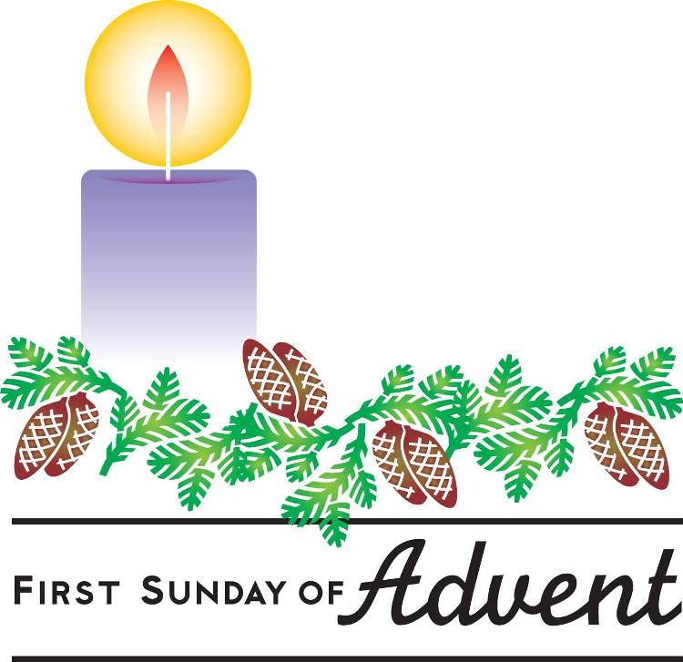

November 27, 2022

10:30 a.m. Worship Service

71 Sparta Avenue
Sparta, New Jersey 07871

Open hearts, Open minds, Open doors:
Not Just a Tagline: This IS who we are

