**SPARTA**

**UNITED METHODIST CHURCH**

*Open Hearts, Open Minds, Open Doors*

March 19, 2023 10:30 a.m.

Prelude *Joy* by Doug Denisen

Flute: Kathy Siegrist

Welcome

*Call to Worship

When the world is dark and full of hate and fear,   
**we will turn on the light.**  
When we cannot find our way back to love and peace  
**we will turn on the light.**  
When our vision dims due to the darkness within  
**we will turn on the light.**  
Christ opens our eyes with the gift of sight.  
**The light of the world is Jesus Christ.**  
Come and worship the one who brings sight to the blind.  
**Praise God for the light of the world!**

*Opening Song *Open My Eyes, That I May See* UMH 454

Opening Prayer

Gracious God, you have created us in your image. We are grateful for all that you have done for us and for all that you are doing in us and through us. Open our eyes to see your presence among us, moving in powerful ways at all times and in all places. Open our ears to hear familiar words in new ways—ways that will change us and challenge us to be the people you created us to be. Grant us the power and the courage to come out of the darkness and into the light of Jesus Christ, that we may serve you by serving others. Empower us to live each day loving you and our neighbors with all our heart, soul, mind, and strength.  We pray this is the name of Jesus, who taught us to pray:

The Lord’s Prayer Ian Good

Bell Anthem *Eternal*  by Jason Krug

A Time for Young Disciples

Anthem *This Is My Commandment*

Words & Music by Larry Shackley

Dramatic Reading of the Gospel *John 9:1-41 (Selected Verses)*

The Message *A Man Born Blind – I See*

This Week in the Life of the Church

Offering of Our Gifts and Our Prayers

*Closing Song *Shout to the Lord* FWS 2074

Sending Forth

Postlude *Slane (Be Thou My Vision)*

Irish Traditional Tune

Setting by Doug Denisen

Flute: Kathy Siegrist

***Thoughts and Prayers***

***Prayers for Allen Koriakin’s brother, Paul Nielsen (Kristi Drew’s father),***

***Sue Gibson, Sharon Gordon, Karen Sutphen, Lester Hemphill, Rich Kelley, Linda Giammanco, Joel, Phoebe Rude, Brenda Losey, Pat Darnstead’s sister, Edith, and prayers for Pat and Tom, her caretakers***

**\*Stand if able**

**WELCOME TO ALL**

Who hope for a better world

& all who have lost hope:

Believers and seekers

Conventional Christians & questioning skeptics

Women, men, youth and children

Of all sexual orientations & gender identities

Of all races and cultures,

Of all income levels

Of all social classes

Of all physical & mental abilities.

***COME AS YOU ARE . . .***

***YOU ARE WELCOME!***

SPARTA

UNITED METHODIST CHURCH

Ministry Team

MINISTERS Every member of Sparta UMC

PASTOR Rev. Dr. Steven Bechtold

PASTOR EMERITUS Rev. Dr. Alden Welch

ADMINISTRATIVE ASSISTANT Karen Shaw

DIRECTOR OF MUSIC MINISTRIES Bonnie Pomeroy

DIRECTOR OF YOUTH MINISTRIES & SUNDAY SCHOOL Jack Tironi

SEXTON Eleanor Shumaker

WEBSITE: [www.spartaumc.org](http://www.spartaumc.org/)

*Open My Eyes That I May See*, Words & Music: Clara H. Scott, 1895

*Shout to the Lord*, Words & Music: Darlene Zschech

All Songs One License A-719583

SPARTA

UNITED METHODIST CHURCH

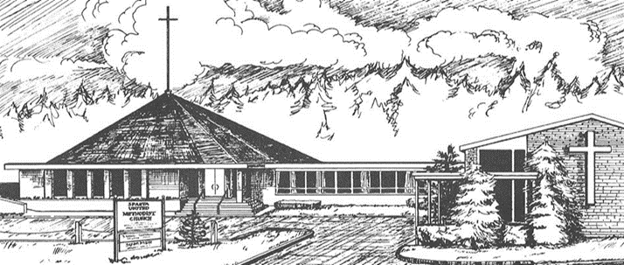

March 19, 2023

10:30 a.m. Worship Service

71 Sparta Avenue

Sparta, New Jersey 07871

*Open hearts, Open minds, Open doors:*

**Not Just a Tagline: This IS who we are**